How many legs does each of these three creatures have?
How many pairs is that? How do you know?
Can you match the animal to the number of pairs of legs it has?
Did you know that legs on living creatures always come in pairs?
  Cat |   Spider |   Bird
  Snake | 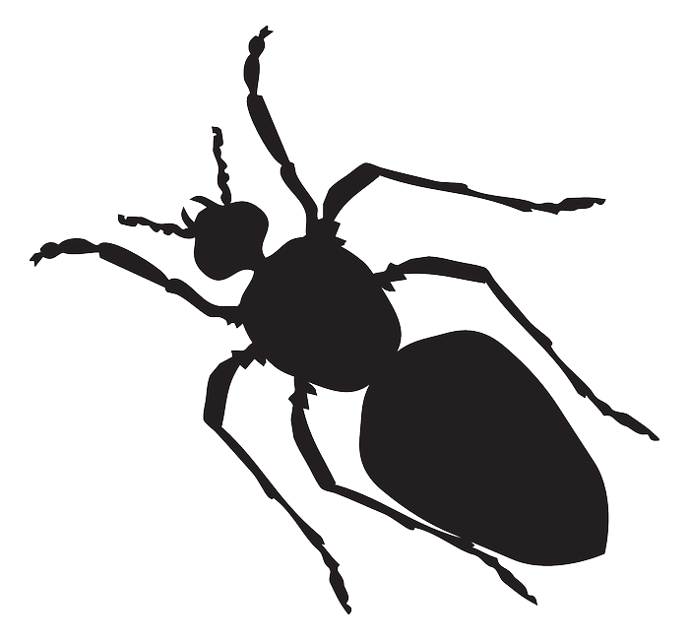  Ant |   Crab
No legs | 1 pair of legs | 2 pairs of legs
3 pairs of legs | 4 pairs of legs | 5 pairs of legs

